**St. Francis Institute of Technology Borivli (West), Mumbai-400103**

**(Autonomous Institute)**

**Department of Information Technology**

**Sub: Internet Programming**

**Experiment – 4: JavaScript Arrow function, Class and Inheritance**

**Aim:** To write a menu driven program in JavaScript to demonstrate the use of arrow function, class, and inheritance.

**2. Objective:** To understand the basic concepts of JavaScript arrow functions, classes and inheritance.

**3. Lab Outcome:** Students will be able to **use** JavaScript to develop interactive web pages (PO3, PO5, PSO3, PSO4)

**4. Prerequisite:** JavaScript

**5. Requirements:** The following are the requirements **–**

• PC/Laptop, Visual Studio Code, Browser

**6. Pre-Experiment Theory:**

JavaScript is the programming language of the Web. JavaScript tis used to program the behaviour of web pages.

In JavaScript we have the following **conditional statements:**

• Use if to specify a block of code to be executed, if a specified condition is true • Use else to specify a block of code to be executed, if the same condition is false • Use else if to specify a new condition to test, if the first condition is false • Use switch to specify many alternative blocks of code to be executed

JavaScript supports different kinds of **loops**:

• for - loops through a block of code a number of times

• for/in - loops through the properties of an object

• for/of - loops through the values of an iterable object

• while - loops through a block of code while a specified condition is true • do/while - also loops through a block of code while a specified condition is true

**JavaScript arrow functions** are a **concise syntax** for writing function expressions. Arrow function should not be used as method or as constructor.

Syntax of arrow function when function body has a **single statement:**

let **myFunction** = (arg1, arg2, ...argN) => expression

Syntax of arrow function when function body has a **multiple statement:** let **myFunction** = (arg1, arg2, ...argN) => {

statement(s)

}

**1 |Internet Programming Lab**

**Example script using arrow function to display Hello World.**

<script>

let hello = "";

hello = () => {

return "Hello World!";

}

document.getElementById("demo").innerHTML = hello();

</script>

**Example script using arrow function for decision making.**

const greater = (a) => (a > 15? a: 15);

console.log(greater (25));

**JavaScript classes** are templates for JavaScript objects. A JavaScript class is not an object. It is a template for JavaScript objects. Use the keyword class to create a class. Always add a method named **constructor**().

For example,

class ClassName {

constructor() { ... }

}

When you have a class, you can use the class to create objects.

**7. Laboratory Exercise:**

**A. Procedure**

• Open Visual Studio Code

• Select File, New, to create a new file, and save it as .html file

• Write html code in html file.

• Write JavaScript either in the html file or

• Write JavaScript in the external .js file and link it into html file.

• To view the output, right-click on the file and select Open With option. Then choose any web browser that is available or check output on console.

• Check the output.

**B. Program Code**

1. Write a Menu driven program in JavaScript to carry out the following to demonstrate the use of control structures and **arrow functions**

1) To take username as input and display Hello Username!

2) To calculate area of a triangle.

3) To display whether number given by user is even or odd.

4) To find greatest number from array of seven numbers.

5) Find Factorial of a number given by user.

2. Write a Menu driven program in JavaScript to carry out the following to demonstrate the use of classes and inheritance -

1) Create a class ‘accholder’ with following attribute as ‘accnum’, ‘name’, ‘age’, and ‘balance’ and print details of two employees using display function.

2) Create a parent class “Calculator” with attributes length, width. Create one derived class named “rectArea” from “calculator” with attribute radius and method to display area of a rectangle. Use super keyword to call parent’s constructor. Then create

**2 |Internet Programming Lab**

derived class “circleArea” from “rectArea” and include method to calculate and display area of a circle.

**8. Post Experimental Exercise:**

1. Write JavaScript arrow function to display a table of number.

2. Write JavaScript arrow function to print Fibonacci series up to 7 numbers.

3. Write JavaScript arrow function to find if the given year is a leap year or not. 4. Write JavaScript arrow function to find the entered number is a perfect number or not. 5. Create two objects **Dog** and **Cat** using **Animal** prototype function. Declare any two properties and

one method of your choice for the Animal prototype. Also write a code to implement any one type of inheritance of your choice.

**9. Results/Observations/Program output:**

• Present the program code and output.

**10. Conclusion:**

• Write what was performed in the experiment.

• Write which all features of JavaScript you used to perform the experiment.

**11. References:**

▪ HTML 5 Black Book (Covers CSS3, JavaScript, XML, XHTML, AJAX, PHP, jQuery) 2Ed., DT Editorial Services

▪ https://www.w3schools.com/js/default.asp

▪ https://www.tutorialspoint.com/javascript/index.htm

▪ https://www.youtube.com/watch?v=W6NZfCO5SIk

▪ <https://www.youtube.com/watch?v=PkZNo7MFNFg>

**B. Program Code:**

1. Write a Menu driven program in JavaScript to carry out the following to demonstrate the use of control structures and **arrow functions**

1) To take username as input and display Hello Username!

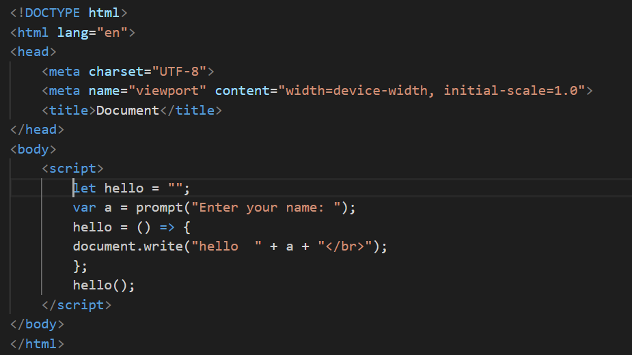

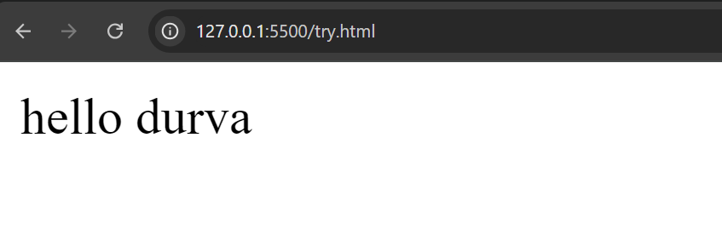

2) To calculate the area of a triangle.

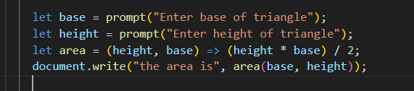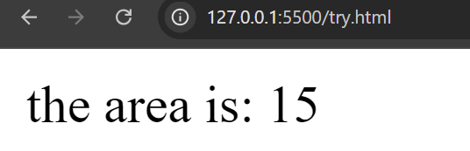

3) To display whether number given by user is even or odd.

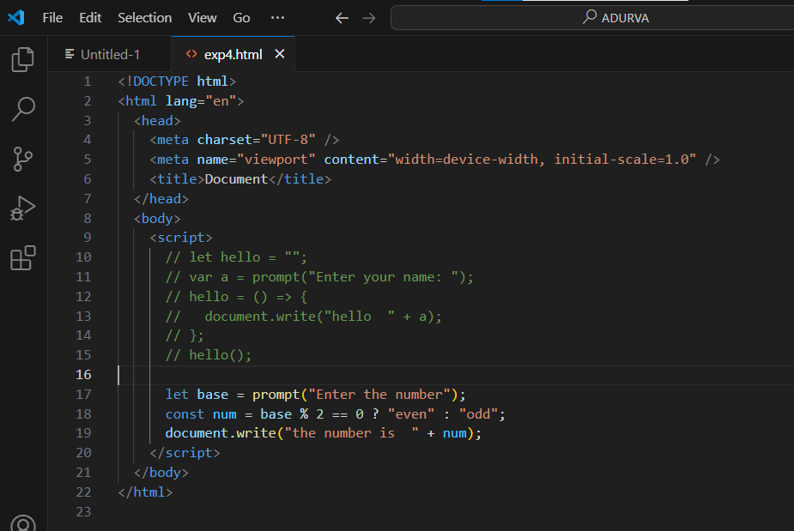 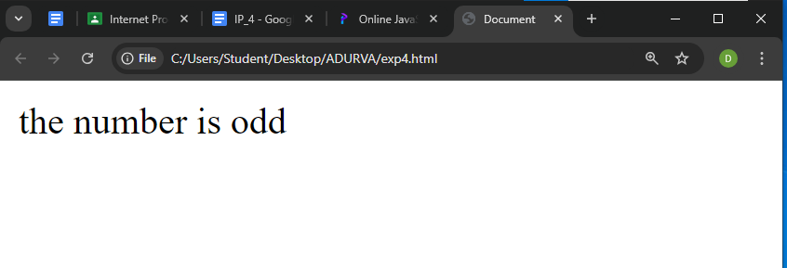

4) To find the greatest number from an array of seven numbers.

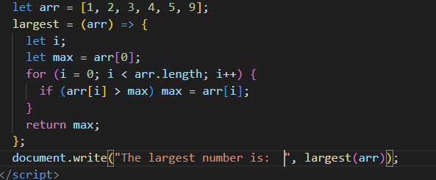

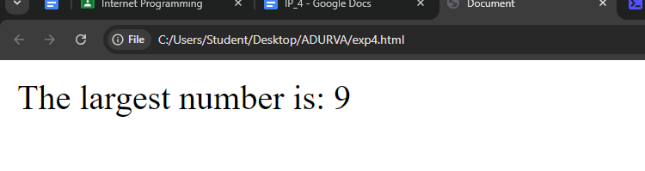

5) Find Factorial of a number given by the user.

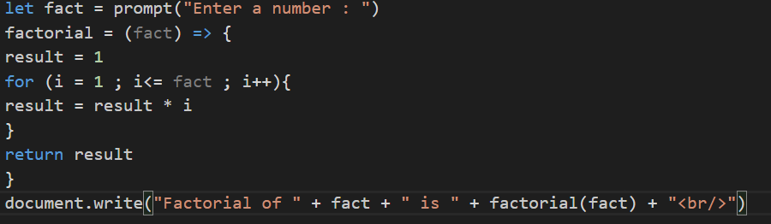

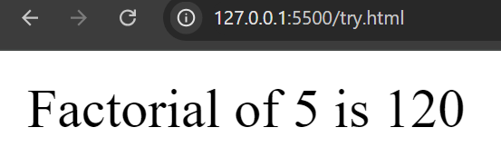

**2. Write a Menu driven program in JavaScript to carry out the following to demonstrate the**

**use of classes and inheritance -**

1) Create a class ‘accholder’ with following attribute as ‘accnum’, ‘name’, ‘age’, and

‘balance’ and print details of two employees using a display function.

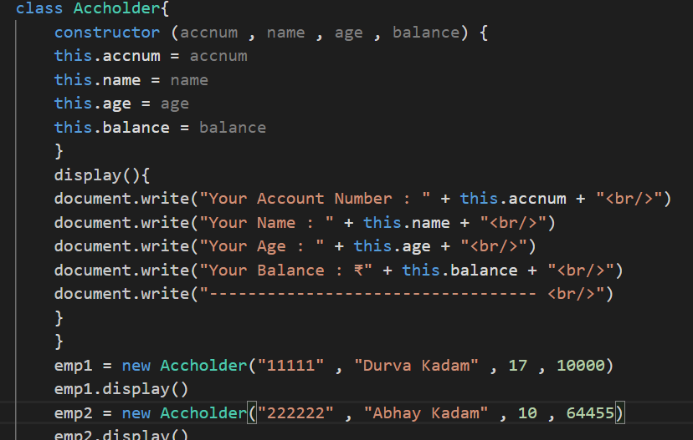

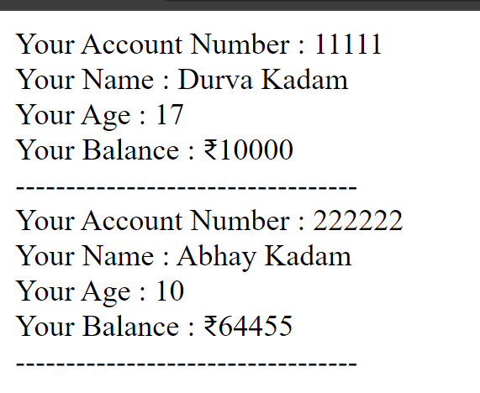

2) Create a parent class “Calculator” with attributes length, width. Create one derived

class named “rectArea” from “calculator” with attribute radius and method to display

area of a rectangle. Use super keyword to call parent’s constructor. Then create derived class “circleArea” from “rectArea” and include method to calculate and

display area of a circle.

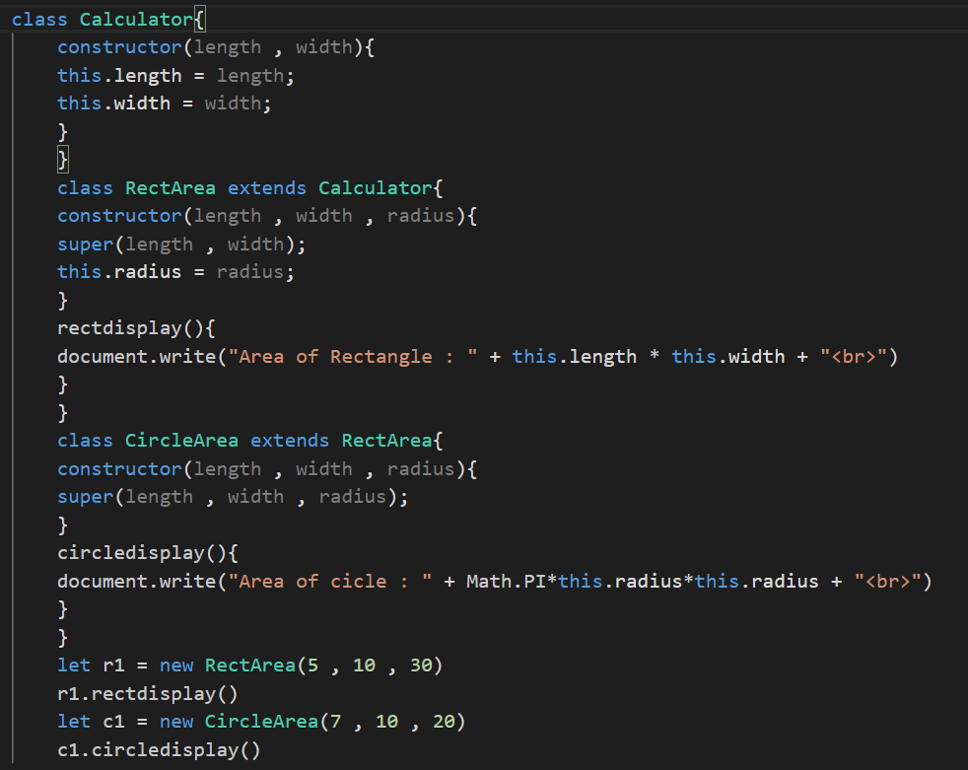



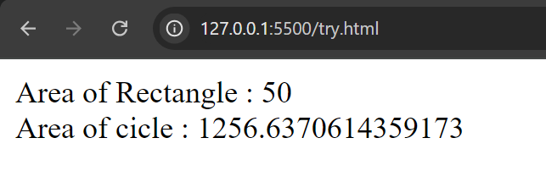

**8. Post Experimental Exercise-**

1. Write JavaScript arrow function to display a table of number.

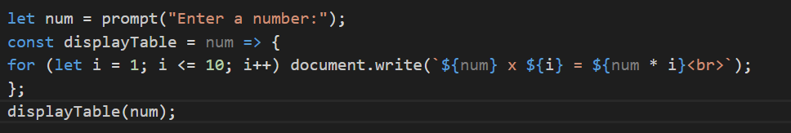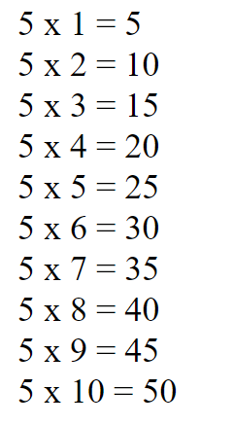

2. Write JavaScript arrow function to print Fibonacci series up to 7 numbers.

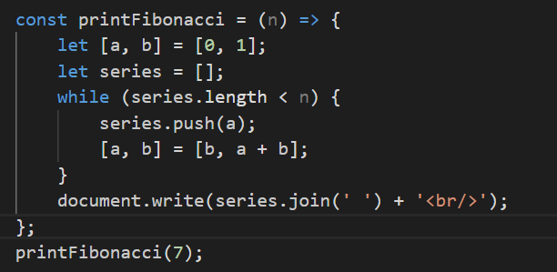

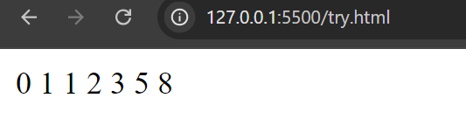

3. Write JavaScript arrow function to find if the given year is a leap year or not.

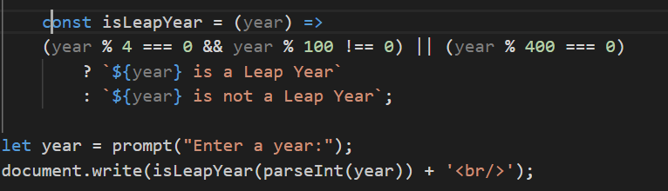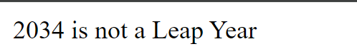

4. Write JavaScript arrow function to find the entered number is a perfect number or not.

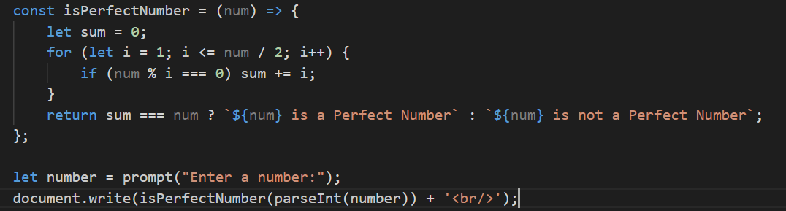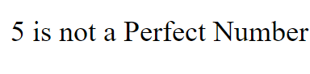

5. Create two objects Dog and Cat using Animal prototype function. Declare any two properties and

one method of your choice for the Animal prototype. Also write a code to implement any one type

of inheritance of your choice.

